Unit 1

Global Citizenship Education (GCE)

Content:

- The World we live in
- The Sustainable Development Goals (SDGs)
- Global Citizenship Education (GCE)
- Service-Learning as a Tool for GCE

Educational Objectives:
Through the content presented in this unit, we’d like to bring you closer to the global context. We also want to introduce the 2030 Agenda and its 17 Sustainable Development Goals (SDGs) as well as the Global Citizenship Education (GCE) and their relevance to achieve a fairer and more sustainable world. Finally, we´ll present Service-Learning methodology as a tool for transformative education to foster active global citizenship.

- The World we live in

Let's briefly outline the general world situation: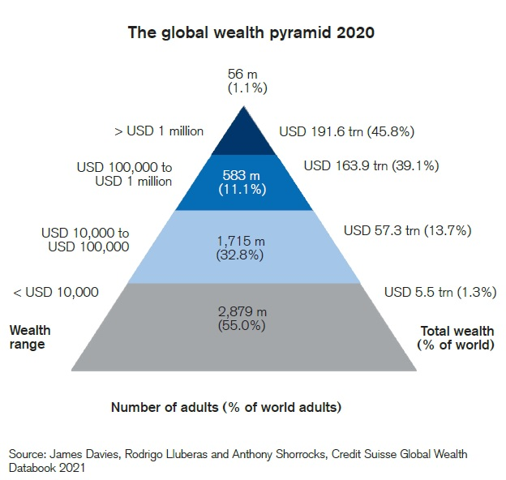

The 2021 Credit Suisse Global Wealth Report reveals that 88% of the world's population possesses 15% of global wealth, while the top 12% controls 85% of all wealth. Fifty-five percent of the world's population manages only 1% of the wealth. Faced with this situation, the immediate conclusion we draw is the "normalcy" of poverty and the increasingly pronounced inequality.

Credit Suisse's statistics, one of the most reliable sources, leave only one possible interpretation: the gap between the privileged and the rest of humanity is enormous. Following the Great Recession of 2007 and, it seems, also the crisis resulting from the 2020 pandemic (although more data is still being collected), the rich are getting richer (in 2020, there are 24% more billionaires than in 2019), and, in many cases, the poor are getting poorer.

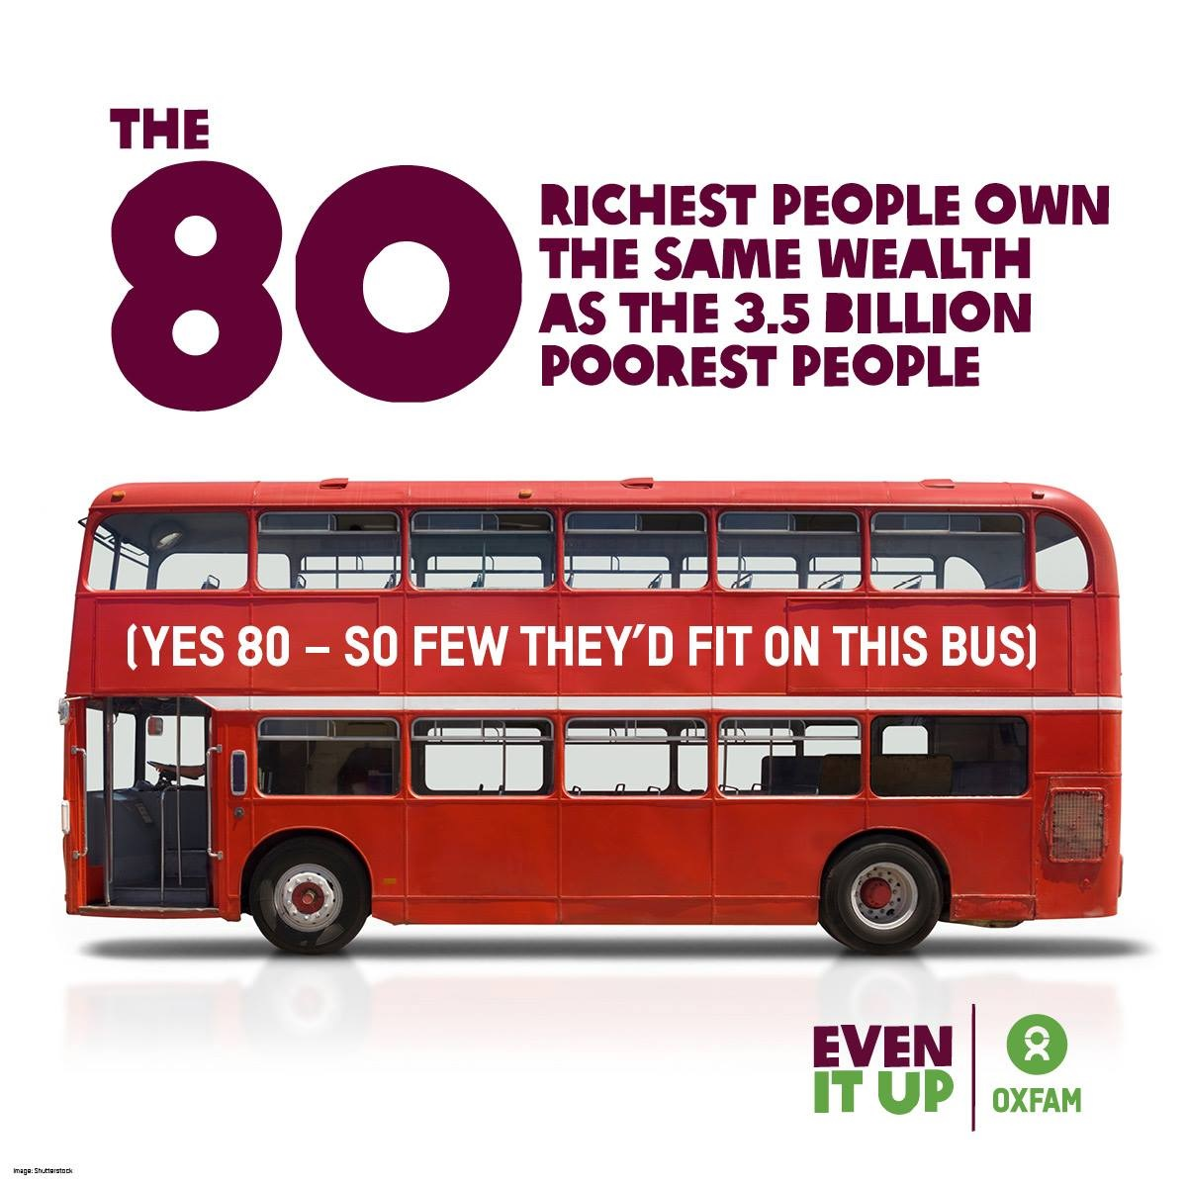

Nobel laureate Joseph E. Stiglitz's book, ‘The Great Divide, What to do about Unequal Societies’ (2015), uses a powerful image from Oxfam to illustrate the scale of the world's inequality problem: a bus carrying 80 of the world's biggest billionaires contains as much wealth as the poorest half of the global population.
Moreover, as Oxfam reflects in its 2022 report "Profiting from Suffering":
"The wealth of billionaires and the profits of large corporations have reached record highs during the COVID-19 pandemic, while more than 250 million additional people could face extreme levels of poverty by 2022 due to the pandemic, rising global inequalities, and the energy and food price crisis, exacerbated by the war in Ukraine. A study by Oxfam has highlighted the following:
• The wealth of billionaires has increased as much in the last 24 months as it has in 23 years.
• The wealth of billionaires in the energy and food sectors has grown by $1 billion every two days. Food and energy prices have reached the highest levels in decades. 62 new billionaires have emerged in the food industry.
• The cumulative crises of the AIDS-19 pandemic, rising inequalities and soaring energy and food prices could push 263 million people into extreme poverty by 2022, reversing decades of progress. This is equivalent to one million people every 33 hours.
• At the same time, during the pandemic, an average of one new billionaire has emerged in the world every 30 hours.
• The flip side of this reality is that, in the same time it takes on average for a new billionaire to emerge, one million people could be pushed into poverty.
The COVID-19 pandemic hit a world already scarred by inequality. Decades of neoliberal economic policies have dismantled public services, which in many cases have been privatised, and have encouraged massive concentration of corporate power and large-scale tax avoidance. These policies have served to deliberately undermine the rights of working people and reduce tax rates for big business and the wealthiest individuals. They have also exposed the environment to levels of exploitation far beyond what our planet can withstand."
We should add that there is overwhelming evidence that climate change is certain and anthropogenic (human-caused). The current economic system depletes the environment, making climate change the greatest challenge we have ever faced.

We understand that the mentioned problems are primarily explained by two interconnected sets of causes: one of an individual nature and the other of a social nature. We believe that the causes of the unjust reality we experience in the world are the prevailing unsupportive values, which contradict the European values outlined in the Treaty on European Union. Additionally, the structures and power relations that sustain poverty and social exclusion worldwide also contribute to this situation. These unjust structures and power relations manifest themselves in the inability to exercise rights, the exploitation of natural resources, and the promotion of irresponsible consumption patterns within an economic system that favors the concentration of wealth in a few hands. This situation is further compounded by the reality of political systems that do not permit the free and equal participation of all individuals.

In this context, the 2030 Agenda represents a global alliance and, at the same time, a call to action to end poverty, protect the planet, and improve the lives and prospects of people worldwide. On the other hand, Global Citizenship Education (GCE), understood as a social movement driving a new model of actively engaged citizenship, is essential for achieving a more equitable and sustainable world where...
- There is equality in the enjoyment of human rights, regardless of race, gender, and social class.
- The goal of the economic system can be to achieve the common good for all individuals.
- It is possible to live in a society that respects the environment, and people consume responsibly.
- Democracy in all its richness and complexity becomes a reality, and individuals exercise their rights and civic duties to the fullest.

- The Sustainable Development Goals

In 2015, the member countries of the United Nations adopted a set of global goals to eradicate poverty, protect the planet, and ensure prosperity for all: The 2030 Agenda for Sustainable Development. This agenda lays out 17 Sustainable Development Goals (SDGs) and 169 associated targets.
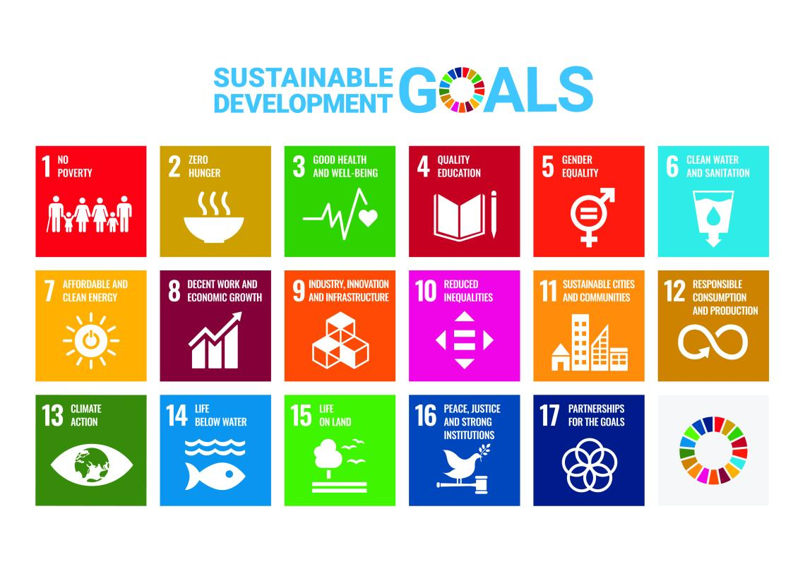
The Sustainable Development Goals (SDGs)

- SDG 1: End poverty in all its forms everywhere.
- SDG 2: End hunger, achieve food security and improved nutrition, and promote sustainable agriculture.
- SDG 3: Ensure healthy lives and promote well-being for all at all ages.
- SDG 4: Ensure inclusive and equitable quality education and promote lifelong learning opportunities for all.
- SDG 5: Achieve gender equality and empower all women and girls.
- SDG 6: Ensure availability and sustainable management of water and sanitation for all.
- SDG 7: Ensure access to affordable, reliable, sustainable, and modern energy for all.
- SDG 8: Promote sustained, inclusive, and sustainable economic growth, full and productive employment, and decent work for all.
- SDG 9: Build resilient infrastructure, promote inclusive and sustainable industrialization, and foster innovation.
- SDG 10: Reduce inequality within and among countries.
- SDG 11: Make cities and human settlements inclusive, safe, resilient, and sustainable.
- SDG 12: Ensure sustainable consumption and production patterns.
- SDG 13: Take urgent action to combat climate change and its impacts.
- SDG 14: Conserve and sustainably use the oceans, seas, and marine resources for sustainable development.
- SDG 15: Protect, restore, and promote sustainable use of terrestrial ecosystems, sustainably manage forests, combat desertification, halt and reverse land degradation, and halt biodiversity loss.
- SDG 16: Promote peaceful and inclusive societies for sustainable development, provide access to justice for all, and build effective, accountable, and inclusive institutions at all levels.
- SDG 17: Revitalize the global partnership for sustainable development.

"The 17 goals are organized into 5 central areas known as the '5 Ps':

- People: Goals 1, 2, 3, 4 y 5.
- Planet: Goals 6, 12, 13, 14 y 15.
- Prosperity: Goals 7, 8, 9, 10 y 11.
- Peace: Goal 16.
- Partnership: Goal 17.

The SDGs are interconnected, which means the success of one affects others. Addressing the threat of climate change impacts how we manage our fragile natural resources. Achieving gender equality or improving health contributes to poverty eradication, and fostering peace and inclusive societies reduces inequalities and promotes thriving economies. In essence, it's an unparalleled opportunity for the benefit of future generations.
The SDGs are relevant as they encompass issues that affect all of us and reaffirm our international commitment to ending poverty everywhere permanently. They are ambitious because their goal is to leave no one behind, and, more importantly, they invite all of us to create a more sustainable, secure, and prosperous planet for humanity. However, solving global challenges and, therefore, achieving the SDGs, depends to a large extent on the level of awareness among the population.

Target 4.7 of the SDG 4-Quality Education:

By 2030, ensure that all learners acquire the knowledge and skills needed to promote sustainable development, including, among others, through education for sustainable development and sustainable lifestyles, human rights, gender equality, promotion of a culture of peace and non-violence, global citizenship and appreciation of cultural diversity and of culture’s contribution to sustainable development

On the other hand, if civil society doesn't demand changes, if we don't make the SDGs matter, it will be difficult to achieve them. Therefore, it's time to talk about Global Citizenship Education (GCE).

- Global Citizenship Education (GCE)

“Even though our world is increasingly interconnected, too great a proportion of the global population lacks an understanding of global challenges, such as inequality, poverty, human rights violations and injustice, which continue to threaten peace and sustainability.
In times of crisis, values like respect, solidarity and inclusion tend to be further weakened.
That’s why Global Citizenship Education plays an important role in building consensus towards a truly sustainable future based on human rights, gender equality, justice and democracy.”
CONCORD

The Spanish NGOs for Development Network (Coordinadora de ONG para el Desarrollo de España) defines "Transformative Global Citizenship Education" as 'a continuous socio-educational process to promote a critical, responsible, and a personally and collectively global citizenship committed to the transformation of local and global realities to build a fairer, more equitable and respectful of diversity and environment world, where all individuals can develop freely and satisfactorily.'

A Global Citizenship has these characteristics...
- Engages actively in civic life at all levels and strives to bring about change.
- Is aware of their rights but also their obligations and takes responsibility for their actions.
- Is interested in understanding and critically reflecting on global issues and how they intersect in their own lives and the lives of others.
- Respects, values, and celebrates diversity and has a cosmopolitan mindset. They are outraged by injustice and exclusion and strive for a better world.

To explain how we can implement GCE proposals in classrooms, the following chart may be helpful:

WHAT IS NOT GCE? | WHAT IS GCE?
It is neither a one-off action in a programme nor an isolated activity. | It is a continuous, interactive and participatory educational process that is on the move. A process that leads to people coming to terms with their own and other people's realities.
It is not celebrating the day of... | It is a continuous process of active education to enable a process of analytical and critical reflection of citizens.
It is not something for NGOs to spend a day in the classroom. | It is the integration of NGO actions into the school year programme.
It's not just education in values. | It is an education that involves linking economic aspects with political, historical, environmental, human rights and equity elements. It is an education that has social justice and human rights at its core.
It is not just to talk about interculturality. | It is the real integration of cultural, religious, linguistic, etc. diversity in the educational processes that take place in schools through actions specifically designed for this purpose.
It is not only Development Cooperation. | GCE actions are open to citizens and promote their participation and mobilisation in the construction of a fairer world.
It is not talking about what NGOs do. | NGOs are actors in GCE alongside public administrations, educational communities, the media, professional organisations, etc.
This is not a space to talk only about the problems of impoverished countries. | It is a space to talk about the problems of the global world, the responsibility of the rich countries, the repercussions of an economic system that condemns a large part of the planet's population to poverty, the relationship between our lives and those of people in other countries, it is a space for reflection on global and local relationship and its consequences and for building alternatives.
GCE does not only take place in the compulsory education system. | GCE has a place at all levels of education, from kindergarten to university, and outside school: in our neighbourhood, city, in the media, etc.
GCE does not rely exclusively on awareness-raising activities. | GCE's actions are varied, it´sawareness raising but also education-training, research, advocacy and social mobilisation.

- Service-Learning as a Tool for Global Citizenship Education (GCE)

As philosopher Adela Cortina asserts, in an unequal and unjust world, "the purpose of education should be to shape citizens capable of transforming the world." In other words, education aims to cultivate social awareness and commitment to foster active global citizenship.
Furthermore, it has long been evident that a change in education is necessary to align with the current century and adapt to the needs of the present reality. Education should be functional, where learning has meaning.
Service-Learning (SL) emerges as a specific proposal that addresses both of these educational realities

‘Service-Learning (SL) is an educational approach that combines learning processes with community service in a well-structured project where participants learn while addressing real needs in their environment with the aim of improving it’
Definition by the "Centre Promotor d’Aprenentatge Servei" of Catalonia
.

In other words, SL is a way to learn while serving the community. It is a method to link educational success and social commitment.
Experience shows that when service-learning projects are carried out, a "virtuous circle" is produced, since academic learning improves the quality of the service offered; the service demands better comprehensive training, stimulates the acquisition or production of new knowledge to adequately resolve the need detected, and all of this results in greater citizen commitment.
Learning improves the quality of the service offered and the service has an impact on better comprehensive training and stimulates a new production of knowledge.

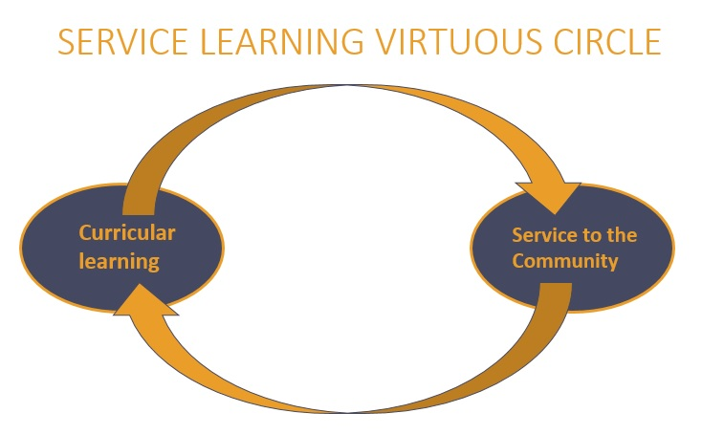

According to Roser Batlle, four ingredients can be identified in almost every SL project:
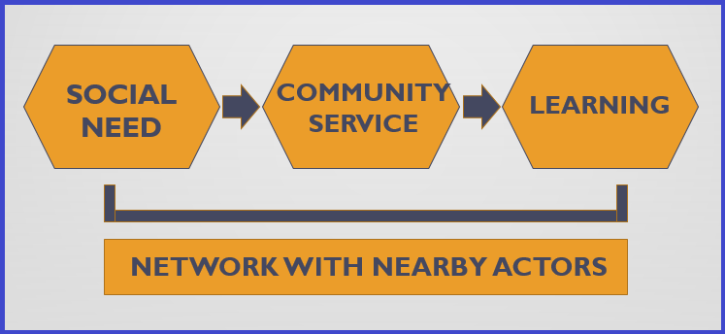

In general, we can say that:

- The starting point is a social need or problem (either local or global) that can clearly be improved.
- Community service is organized as a response to that need.
- All of this provides meaningful learning experiences for students.
- Generally (with some exceptions), it requires collaboration and networking with local stakeholders and the community itself.
Service-Learning (SL) serves as a tool for global citizenship education in the sense that through projects, it can address the Sustainable Development Goals (SDGs) and their targets, investigate and establish connections between local and global issues and needs, and carry out actions for social transformation.

In the next unit, we will delve into this methodology and explore some examples of SL projects with a focus on global citizenship.

Funded by the European Union. Views and opinions expressed are however those of the author(s) only and do not necessarily reflect those of the European Union or the European Education and Culture Executive Agency (EACEA). Neither the European Union nor EACEA can be held responsible for them.

CONCORD is the European Confederation of NGOs working on sustainable development and international cooperation. https://concordeurope.org/about-us/

