Unit 3

Guidelines for carrying out a Service-Learning project with a Global Citizenship approach

Content:

- European common values and SDGS (Sustainable Development Goals)
- Guideline 1: Identify needs related to common values
- Guideline 2: Think of a global active citizenship service that addresses that need
- Guideline 3: Learn by doing! determine the learning necessary to provide the service that addresses that need.
- Guideline 4: identify which of those learnings are included in the curriculum and develop the educational project.
- Guideline 5: Network, work as a team. involve as many stakeholders as possible.

Annex:
- Template for outlining a SL proposal based on 5 basic questions
- Template for designing a SL proposal

Educational Objectives:
In this unit, we will introduce ‘European common values’ and their connection with the Sustainable Development Goals (SDGs). We will also provide you with five basic guidelines for creating SL proposals with a global citizenship approach. Finally, we will share two templates; one of them can help you outline an SL project idea and the other includes all the elements to guide you in designing a complete SL proposal.

- European common values and SDGS

The European values are mentioned in Article 2 of the Treaty on European Union:
"The Union is founded on the values of respect for human dignity, freedom, democracy, equality, the rule of law, and respect for human rights, including the rights of persons belonging to minorities. These values are common to the Member States in a society characterized by pluralism, non-discrimination, tolerance, justice, solidarity, and equality between women and men."

These values align with the values promoted by Development Education or Global Citizenship Education:

‘Development education is the education that opens the eyes and minds of individuals to the realities of the globalized world and awakens them to strive for a world of greater justice, equity, and human rights for all’.
Maastricht Declaration, 2002

‘Development education is a pedagogical approach that promotes multiple perspectives and the deconstruction of stereotypes. It is based on a student-centered approach to foster critical awareness of global challenges and a commitment to sustainable lifestyles. The competencies of Global Education are based on development education, human rights education, sustainability education, peace education, conflict prevention, and intercultural education, all of which constitute the global dimension of citizenship education’.

North-South Centre of the Council of Europe

‘Global Citizenship Education aims to empower students of all ages to take active roles, both locally and globally, in building more peaceful, tolerant, inclusive, and secure societies’.
UNESCO

As a result, these 'common values' are aligned with the Sustainable Development Goals (SDGs) of the 2030 Agenda, especially with its Goal 4.7, which we discussed in the content of Module 1.
Below, we provide you with 5 guidelines for carrying out Service Learning (SL) projects with a global citizenship approach.

- Identify needs related to common values or, in other words, to the SDGs (Sustainable Development Goals).

Human rights, sustainability, interculturality, gender equality, social justice... the list of common values and their associated content is extensive and aligns perfectly with the 17 Sustainable Development Goals of the United Nations' 2030 Agenda.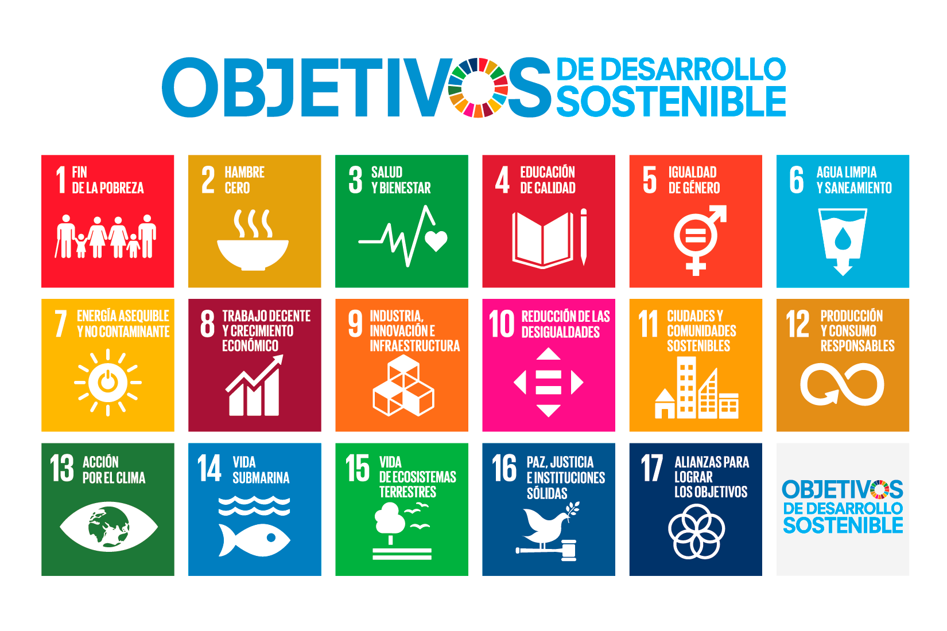
Linking the identified need to the SDGs allows students to place a local need within a global framework and helps them realize that they are not only addressing a specific, local problem but also contributing to a greater good. In this way, we begin to put into practice the maxim "Think globally, act locally."

Furthermore, relating the identified need to one or more common values is crucial for reflecting on that need. Reflecting on a need from a global education perspective involves asking the following questions:

- What are the causes of the problem we have identified? Are there global or only local causes? What are the consequences?
- Who is responsible for this situation? Who has the power to reverse this situation?
- What can we do as citizens?

- Think of a global active citizenship service that addresses that need.

Some students may find any Service Learning (ApS) project interesting, but for others, their interest will depend on the appeal and utility of the service. So, involve them in choosing the service, strengthen their participation, and encourage their initiative. However, it's important to be clear that the service should not be chosen or developed frivolously ("I like it," "I don't like it"), in a self-sufficient manner ("we know what to do"), messianic ("we're going to save the world"), reckless ("we can do it all"), or as an act of charity ("they should be grateful"). The benefit that students should pursue is learning and the benefit of the solidarity action should be entirely for the community.

How to Improve the Global Perspective of Your Service Learning Project?

The park in your neighborhood is dirty and abandoned and you and your students decide to clean it up, carry out an awareness campaign in the neighborhood and petition the city council to restore it. This service would be an example of active citizenship in action, but without knowing more details we cannot know if it is an example of GLOBAL active citizenship in action. If the content of the awareness campaign is reduced to cleaning and caring for the park, the global vision will be scarce; but if the awareness campaign talks about the problem from a planetary perspective or frames the dirtiness of the park in the problem of waste generation and consumerism, the global vision will be much more present.

Another way of reinforcing the global perspective of the service is by applying a human rights promotion approach instead of a welfare approach. To help vulnerable people you have to give them confidence, not treat them only or mainly as helpless, but focus on their potential. This does not mean not paying attention to their minimum rights by offering the necessary assistance, but if they only receive assistance, they end up being treated unfairly, since they are not recognized for their ability to progress.

- Learn by doing! Determine the learnings necessary to provide the service that responds to that need

As we mentioned in Module 2, the content of these learnings can be grouped into four categories: 'learning to know,' 'learning to do,' 'learning to be,' and 'learning to live together.' Within these categories, we can identify 12 basic learning contents:

Learning to know...

- Specific social and environmental challenges
- Social organizations, NGOs, citizen initiatives, and committed individuals
- Local-global connections and a more complex worldview

Learning to do...

- Carrying out and managing projects
- Specific skills and competencies related to the service being provided
- Personal skills and talents in service to others

Learning to be...

- Personal autonomy
- Internalization of values
- Critical thinking and the capacity for commitment

Learning to live together...

- Teamwork
- Prosocial attitudes and coexistence skills
- Communication skills

Given that 'Service' involves taking action, and through the Service-Learning methodology, students learn by doing, let's focus on the 'learning to do' category and the learning contents that students can develop through the action of the service:

- Skills in carrying out and managing projects. Developing and executing projects involves learning how to organise, manage resources, plan, etc. In the first projects, students will need a lot of help, but they will become more and more autonomous.
- Skills and competences specific to the service being developed. Each project will also provide specific learning. If the service consists of storytelling to young children, the specific learning will be such as intonation, non-verbal language, oral expression... But if the service consists of helping to rehabilitate a soup kitchen that has been damaged by a flood, the learning will revolve around the packaging and preservation of food, use of cleaning utensils, etc.
- Hobbies, skills and personal talents at the service of others. An SL project can also favour the development of individual skills and hobbies in a community service context. Thus, following the storytelling example above, a pupil who can sing can include a song in the storytelling, or a pupil who can draw can make a poster advertising the storytelling.

- Identify which of these learnings are included in the curriculum and prepare the educational project

There is a lot of valuable and necessary learning that may not be included in the school curriculum; moreover, if we take into account that the L2S project is developed in Croatia, Spain and Italy, there will be contents that are included in the curriculum of one country and excluded in another. On the other hand, it is impossible to design an activity in which pupils learn only the content that the teacher sets. Unexpected or uncontrollable learning takes place. Therefore, there will be extracurricular learning in our SL projects. So, we must, first of all, think about the learning that, as a teacher, I want my students to have, and then classify this learning into curricular and extracurricular.

Why is it important to incorporate and specify learning required by the curriculum?

- Because in this way we fight the idea: "What we learn at school is useless in real life". In this way we contribute to making school learning useful.

- Because if school learning is useful, students will see the meaning of the subjects and we will increase their interest, motivation and commitment to the teaching and learning process.

- Because it makes it easier for the pupils' families to be favourable towards SL projects. Sadly, there are many families (and teachers) who are wary of solidarity school activities because "it takes time away from the pupils to learn what they have to learn", "if the teacher instead of taking the children to clean the park was teaching maths, language, history... maybe he/she would have time to teach the whole course syllabus". But if, instead, our project includes curricular learning, we can use this to win families over and, in this way, they will be in a better position to also accept and understand the importance and value of non-curricular learning, because they are indivisible from curricular learning.

In any case, whether we decide to include curricular learning or not, it is essential to draw up a rigorous project that includes, at least, the following sections: justification, objectives, contents, assessment, activities, timing, methodology.

Regarding the assessment, the whole experience must be documented because it is important to reflect the process and the results as well as to be able to self-evaluate what has been achieved. The ability to reflect and learn from experience is an element of quality. The SL approach allows us to reduce a double distance: on one hand, that which exists between academic learning and real life, and on the other, that which exists between the values that are preached and the values that are experienced.

- Network, work as a team. Involve as much actors as you can: social entities linked to the target need, students’ families, public entities...

We do not live in isolation and the causes and consequences of problems are often multiple, therefore, we need to collaborate with other actors: if the need of the social environment that we have identified is that the neighbourhood park is dirty and abandoned, we will have to at least knock on the door of the city council (to gather information and ask them to take charge), of environmental organisations (to gather information and assess whether they have any services to offer us) and of the neighbours (to gather their demands and to invite them to an awareness-raising activity). Networking, therefore, is inevitable.
Changing a culture of working in isolation for a culture of networking means sharing a project or doing something new together, it means sharing ownership and commitment and it means that each party does and contributes what is its own.
As it is a school proposal, it is the teacher and/or the school who leads, promotes and guides the SL project; therefore, it is also the one who has the responsibility to involve other actors. The level of participation of those actors will depend on several factors: collaboration history, capacity, willingness, availability, tasks... but we must make it clear to them that they can be involved as much as they wish, since the deeper the participation, the more valuable and deeper the results and learning will be.
The partners that make up the consortium of this project believe that for children's education to be as effective as possible, the school and families must work together. For this reason, we will promote the participation of families in the SL lesson plans. The school must be open to families, take them into account and involve them in the school educational process.

Here below you´ll find two templates that will help you design your Service Learning (ApS) project. Remember that in the virtual classroom, you will find the book "100 Good Practices in Service Learning" to inspire you. (Please, change this reference if you don´t consider it adequate for your country)

Annex 1: Template for outlining the basics of an SL project
Based on a proposal by Paco Barea Durán (School teacher)
SERVICE
Write it clearly defined here...

NETWORKING
Write it down here...

Describe it briefly here...
Explain it concretely and briefly here...

LEARNING
(COMPETENCES, IDEAS, SKILLS, ATTITUDES AND VALUES)
List the main ones here...
ROLE OF FAMILIES
PROBLEM/NEED

Annex 2: Template to design a SL project
The following template is based on one created by the Spanish network of SL, which in turn is an adaptation of Ana Aguilar de Armas's Manual for Solidarity Teachers and Students of CLAYSS.
This is just one possible template, which allows us to review the key aspects of designing a service-learning project. It is not an essential itinerary to follow to the letter, because it depends on different factors such as the organizational culture of each school center or social entity that promotes the project.

Project technical specification
Project name
School or entity in charge
Participating students (number and school year)
Subjects or areas of the project
Other entities involved
Target persons

Project proposal
 | Guiding questions | Fill this column with your own project
Project synopsis | Can you describe in a few lines what the project is about so that it is understood at first glance?
Social need to be addressed | What is the problem or social need on which your students are going to work?
Service | What is the service action that your pupils are going to carry out?
Link with the SDGs | What SDG(s) is/are this project linked to?
Educational needs of your students | What characteristics do your students have and what do they need to improve?
Educational objectives and/or competencies that will be worked on | What are the key learnings that can be strengthened with this project?
Evaluation | How will the acquisition of competencies (pursued learning) be evaluated? (Remember to schedule activities and times to collect information that evidences the acquisition of learning throughout the process)  How will the service provided be evaluated?  How will the project itself be evaluated?
Activities | What are the activities that the students will develop in this project?  Remember to propose activities for the different phases (motivation, analysis of the problem, reflection...) as well as the activities that will be carried out with the service.  Point out those inside and outside the classroom.  Indicates the key methodological aspects
Activities Calendar | What are the activities that boys and girls develop in this service?
Students’ leading role | Point out the ones inside and the ones outside the classroom.
Students’ families role | How are we going to get the families involved? As a dissemination target? As an active part of the project?
Networking | What will be the participation of the collaborating entities?
Celebration | How are we going to celebrate the project?
Dissemination | How are we going to spread the project?
Means | What is needed to carry out the proposed activities?

Disclaimer: Funded by the European Union. Views and opinions expressed are however those of the author(s) only and do not necessarily reflect those of the European Union or the European Education and Culture Executive Agency (EACEA). Neither the European Union nor EACEA can be held responsible for them.

At the end of these guidelines (see Annex 1 and 2) you will find templates to create your lesson plan

